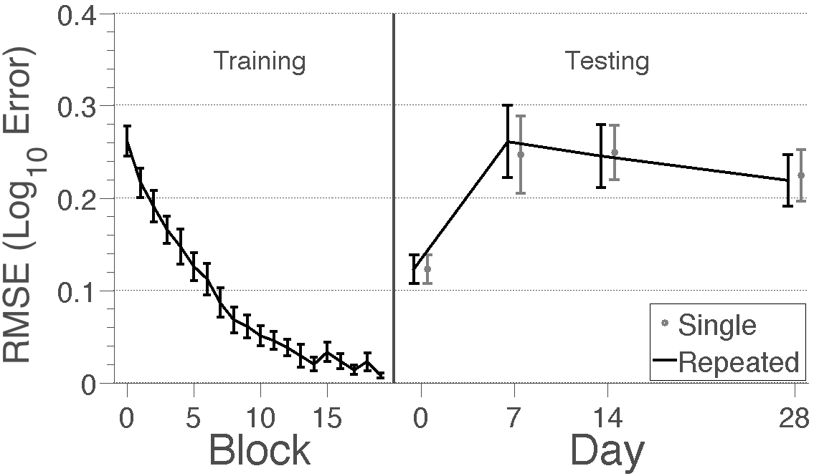
Figure 9. Learning and forgetting curves for Experiment 4. Error was measured in log₁₀ root mean square error (RMSE). The first 20 blocks of training is left (in Blocks) and testing is right (in Days). Because subjects completed training in different numbers of blocks, we imputed their results for subsequent blocks in the learning curve to avoid misrepresenting errors in later blocks (our analyses do not rely on these imputed values). For testing, the continuous black lines indicate facts that were tested every session and the grey points indicate facts that were only tested in that session. Subjects learned the locations during training and appeared to return to baseline after one week. Error bars indicate ±1 SEM across subjects.

